ABSTRACT title here (15 words max)

Author One ¹, Author Two ², Author Three ²
1. Institution, Melbourne, VIC, Australia
2. Another Institution, Sydney, NSW, Australia

The header consists of 10 lines with 14 point spacing.

The last line below should be left blank.

Keywords
Please list a minimum of three (3) keywords

EXECUTIVE SUMMARY (100 words maximum)
If submission is successful, the 100 words will be used in pre-event promotion as well as the conference app.

introduction
This document explains how to prepare an extended abstract for submission to the Conference. It also includes the instructions for submission and some additional information. This document can be used as a template with MS-Word.

It is important this template is adhered to as all abstracts accepted for presentation at the event will be printed as submitted.

HIGHLIGHTS
Highlights are a short collection of bullet points that convey the core findings and provide readers with a quick textual overview of the abstract/paper
- Include 3 to 5 highlights
- There should be a maximum of 85 characters, including spaces, per highlight
- Only the core results of the paper should be covered

Example (Journal of Health Economics, Vol 29, Issue 4, 524-535):
- We model two hospitals which have regulated prices and compete on quality
- We examine changes in the level of information about hospital quality
- Increasing information will increase quality if hospital costs are similar
- Increasing information will decrease quality if hospital costs are very different

METHODOLOGY/ PROCESS
Please use the headings “Introduction”, “Highlights”, “Methodology” (or “Process”), “Results” (or “Outcome”) and “Conclusion” as per this template – capitalised and underlined. Any subheadings should be bolded.

Page Limit
Maximum 2 pages of text followed by a maximum of 3 pages of supporting tables and graphics.

Page Size and Layout
The paper should be prepared for A4 size paper (210 x 297mm), with overall margins of 20mm on all sides of the paper (top, bottom, right and left). Use font type Arial for the entire document. Justify text.
Do not include page numbers, headers or footnotes.

Heading
The top section of the first page of the paper should contain the paper title, author list, and affiliations. This section must consist of 10 lines (whether filled or blank).

Titles must be in 12-point font, bold and capitalised. Do not use more than two lines for the title, and try to limit the title to ten words.

Authors and affiliations must be in 10-point font. Authors with more than one affiliation should indicate additional affiliations by numbers, superscripted following the author’s name.

Affiliations must be entered as follows: Organisation, City/ Town, State (abbreviated), Country
(e.g. Australian Water Association, Sydney, NSW, Australia)

RESULTS/ OUTCOMES

References
Do not include references or acknowledgements in this abstract. If the abstract is accepted for presentation, references can be included in the final paper.

Figures and Tables
Figures and tables, both of which must have numbers and captions, can be included in a maximum of 3 pages at the end of the abstract. Colour images are welcome. Refer to page 3 for examples.

Equations
Mathematical equations should be created using equation editor in Word. Equations should be centred between left and right margins and be separated by a blank line. All equations should be sequentially numbered using numbers in parentheses along the right margin.

Submission Instructions
- Maximum 2 pages of text followed by a maximum of 3 pages of supporting tables and graphics.
- Ensure you run a spell-check and ask a peer to proof your abstract prior to submitting.
- Convert this document to PDF format before submitting.
- Files larger than 10MB should be compressed as they are too large to upload.
- Upload your abstract through the conference website.
- If your abstract does not meet the submission requirements, it will not be processed for review.

Conclusion
This document has described how to prepare an extended abstract for submission. It is derived from the author guidelines used for all Association conferences and events.
Figure 1 is an example of a graph in the text with a caption below the figure. Please include a blank line above the figure and below the caption. The caption should be in italics.

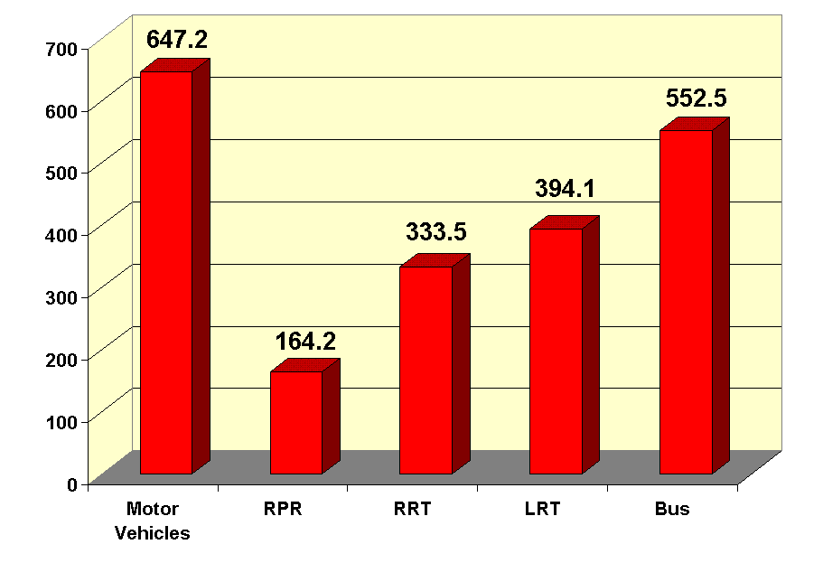
Figure 1: Example of a Figure

Table 1 shows an example of a table, where the caption should be on the top of the table.

Table 1: Example of a Table
Heading 1 | Heading 2 | Heading 3
Entry 1 | Entry 2 | Entry 3

Figure 2 is an example of an oversized figure.

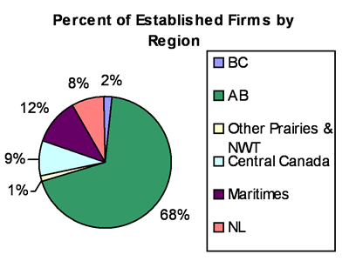

Figure 2: Example of an Oversized Figure

